Brendan Behan at 100 : Legacy and New Directions
23-24 June 2023

EXTENDED DEADLINE FOR ABSTRACTS 5 MARCH 2023

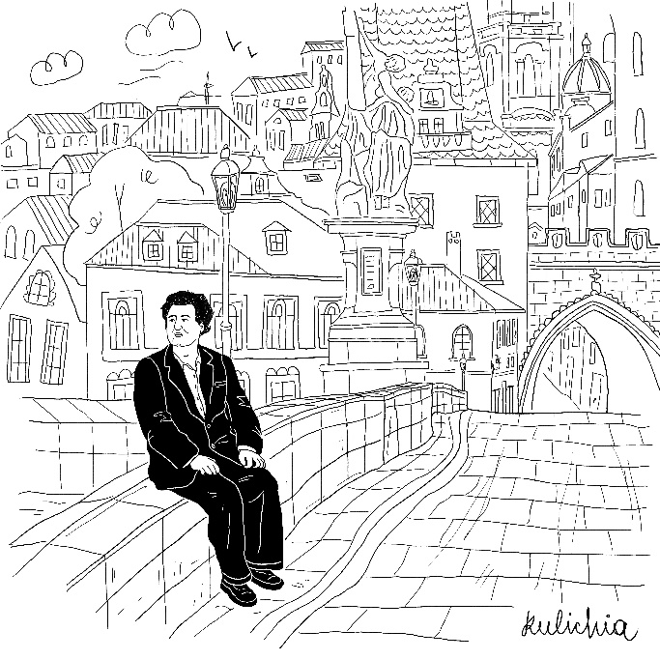
Hosted by the Centre for Irish Studies, Charles University, Prague
Conference venue: Faculty of Arts main building, Náměstí Jana Palacha 2, Prague 1

Keynote speakers
John Brannigan (UCD)
Deirdre McMahon
TBD

Irish author, playwright and rebel Brendan Behan was born on the 9th of February 1923. Marking the centenary of his birth, the conference intends to reconsider the rich literary legacy of the proverbial ‘drinker with a writing problem.’ Indeed, for a long time, Behan’s literary achievements were overshadowed by his larger-than-life persona. Recent publications such as John Brannigan’s Brendan Behan: Cultural Nationalism and the Revisionist Writer (2002, 2014) and John McCourt’s edited volume Reading Brendan Behan (2019) have helped to redirect critical attention to the author’s oeuvre. However, to this day, much of Behan’s writing remains critically neglected, the focus having often been exclusively on his plays The Quare Fellow (1954) and The Hostage (1958), as well as his autobiographical novel Borstal Boy (1958). Thus, the conference intends to highlight Behan’s lesser-known works, be it his Irish-language writing, his short stories, columns or radio plays, as well as encourage new approaches to his entire oeuvre. The unmatched empathy with which Behan writes not only about Dublin’s working-class community, but also criminals, rebels, artists, drunkards, British army pensioners and prison guards is only one of the features that make his writing relevant to this day. ‘Dublin’s Laughing Boy’ was known well across the borders of Ireland and his unique wit, openness to collaboration and insight have surely earned him a place among the greats of Irish literature.

We invite contributions that seek to engage with the following and related areas in particular:

- Behan’s prose writing, including the “talk books”
- Behan’s poems and drama in Irish
- Behan’s relationship to the Irish language
- Behan in translation
- Behan’s songs
- Behan’s legacy in literature, music and the arts
- Behan and other mid-century writers
- Behan and life writing
- The Behan family
- New takes on common themes (Irish Republicanism, religion, the Dublin working class)

Please send abstracts of 250 words for twenty-minute papers to brendanbehan100@gmail.com by 5 March 2023. These must include the title of the paper, name of the presenter, e-mail address and a bio-note of 150 words. The conference is planned as an in-person event.

Registration deadline:
15 May 2023

Projected registration fee:
EUR 60 (waived for students)

Conference committee:
Nathalie Lamprecht, Marie Gemrichová, Klára Hutková, Ondřej Pilný

