

**CAIS/ACEI KEYNOTE SPEAKERS FOR 2023**

**OTTAWA, ONTARIO, CANADA**

**Jan Carson** is a writer and community arts facilitator based in Belfast, Northern Ireland. She has a novel, *Malcolm Orange Disappears* and short story collection, *Children’s Children*, (Liberties Press), two micro-fiction collections, *Postcard Stories 1 and 2* (Emma Press) and a short story collection, *The Last Resort* (Doubleday). Her novel *The Fire Starters* (Doubleday) won the EU Prize for Literature for Ireland 2019, the Kitschies Prize for Speculative Fiction 2020 and was shortlisted for the Dalkey Book Prize 2020. Jan won the Harper’s Bazaar short story competition in 2016 and has been shortlisted for the BBC National Story Prize (2020), Sean O’Faolain Short Story Prize (2016) and the An Post Irish Short Story of the Year Award (2021). Jan’s latest novel, *The Raptures* was published by Doubleday in early 2022 and shortlisted for the 2022 Kerry Group Irish Novel of the Year Award. Jan’s work has been translated into over a dozen different languages. The Fire Starters was shortlisted for the Strega European Prize (Italy) and both The Prix Femina International and Prix Medici International (France). Both The Fire Starters and The Raptures have been optioned for screen and are currently in development. Jan is the ARIEL Writer in Residence at the Université de Lorraine, France 2022-23.

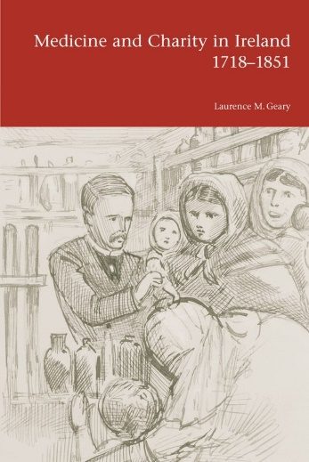**Laurence Geary** is a retired Senior Lecturer in History at University College Cork. He has held academic appointments at the Australian National University, Canberra; the University of Melbourne; the University of Edinburgh; the Royal College of Surgeons in Ireland. His publications include *Medicine and Charity in Ireland, 1718-1851* (Dublin: UCD Press, 2004), and *The Land War in Ireland: Famine, Philanthropy and Moonlighting* (Cork: Cork University Press, 2023). Laurence’s talk is entitled **“Famine, Disease, and Death in Modern Ireland”.**

**Michael McBane** is the author of *Bytown 1847: Élisabeth Bruyère & the Irish Famine Refugees* (2022) and *Ill-Health Canada: Putting Food and Drug Company Profits Ahead of Safety* (2005). He has been a staunch advocate for public health care and improved public services and is past national coordinator of the Canadian Health Coalition.

Michael’s talk is entitled**: “Valley Irish, Famine Migration, and the Development of Public Health in Ottawa”.**

**Ida Milne** specializes in the history of infectious disease in the 19th and 20th century from a global as well as Irish perspective. Her PhD (TCD 2011) was on the social and political impact of the 1918-1919 influenza pandemic in Ireland. The resulting book, *Stacking the Coffins, Influenza, War and Revolution in Ireland, 1918-19* was published in 2018. Named as one of Choice Reviews Outstanding Academic Titles for 2019, it has been described as the authoritative work on the Spanish flu in Ireland, and a handbook to look at history of pandemics in Ireland during COVID-19. Ida is also interested in media history, sports history, and the histories of Protestant identity in Ireland. With Ian d’Alton, she co-edited *Protestant and Irish, The Minority’s Search for Place in Independent Ireland*, published in 2019. Ida is currently a Lecturer in European History at Carlow College, Visiting Research Fellow at the School of Histories and Humanities in Trinity College Dublin. She also serves as Co-Chair of the European Social Sciences History Conference Health and Environment Strand, as a Member of the Royal Irish Academy historical sciences committee, Co-Chair of the Oral History Association [USA] international committee, and Chair of the History of Science, Technology and Medicine Network in Ireland.

Ida’s talk is entitled: **“The Covid Diary of an Accidental Public Historian: The Application of Historical Research to Present-Day Crises”.**

**Matthew L. Reznicek** is Associate Professor of English in the College of Arts and Sciences and Associate Professor of Medical Humanities in the School of Medicine at Creighton University, Omaha, United States. He teaches Nineteenth-century British and Irish Literature, Literary Theory, and Medical Humanities, Opera and the Novel, and Poverty and the Novel. He previously earned his PhD at Queen’s University Belfast in Northern Ireland. His articles on nineteenth and twentieth-century Irish women novelists have appeared in *Women’s Studies*, *Nineteenth-Century Fiction*, as well as edited collections from Peter Lang and Palgrave Macmillan. His first book, *The European Metropolis: Paris and Nineteenth-Century Irish Women Novelists*, was published in 2017 with Clemson University Press.

Matthew’s talk is entitled: **“Distorted in a Fever: Disease, Disorder, and Social Management in Nineteenth-Century Irish Literature”.**